Verb Phrase (VP) as Head

🟩 What is Verb Phrase (VP) as Head?
# Source: AI Source: Provided by: [Data Path: Persons Table -> ID Column: 1, Name_En Column: Motasem Essam] -> From: [Chatgpt (GPT‑5 Mini)] on [8/7/2025]
In a verb phrase (VP), the head is the main verb — the core around which the rest of the VP is built.
Here's a table of types of heads in verb phrases, based on the form or function of the main verb:
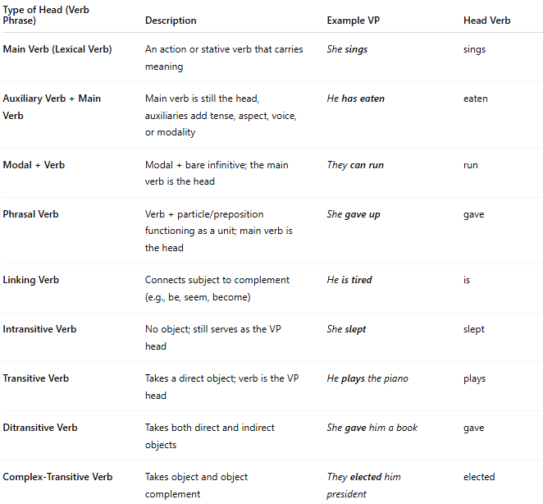
Type of Head (Verb Phrase) | Description | Example VP | Head Verb
Main Verb (Lexical Verb) | An action or stative verb that carries meaning | She sings | sings
Auxiliary Verb + Main Verb | Main verb is still the head, auxiliaries add tense, aspect, voice, or modality | He has eaten | eaten
Modal + Verb | Modal + bare infinitive; the main verb is the head | They can run | run
Phrasal Verb | Verb + particle/preposition functioning as a unit; main verb is the head | She gave up | gave
Linking Verb | Connects subject to complement (e.g., be, seem, become) | He is tired | is
Intransitive Verb | No object; still serves as the VP head | She slept | slept
Transitive Verb | Takes a direct object; verb is the VP head | He plays the piano | plays
Ditransitive Verb | Takes both direct and indirect objects | She gave him a book | gave
Complex-Transitive Verb | Takes object and object complement | They elected him president | elected

✅ Key Note:
# Source: AI Source: Provided by: [Data Path: Persons Table -> ID Column: 1, Name_En Column: Motasem Essam] -> From: [Chatgpt (GPT‑5 Mini)] on [8/7/2025]
In a verb phrase, regardless of how many auxiliaries or modifiers exist, the main lexical verb is the head of the phrase. The auxiliaries are dependents or modifiers.

